Nomenclature Terms
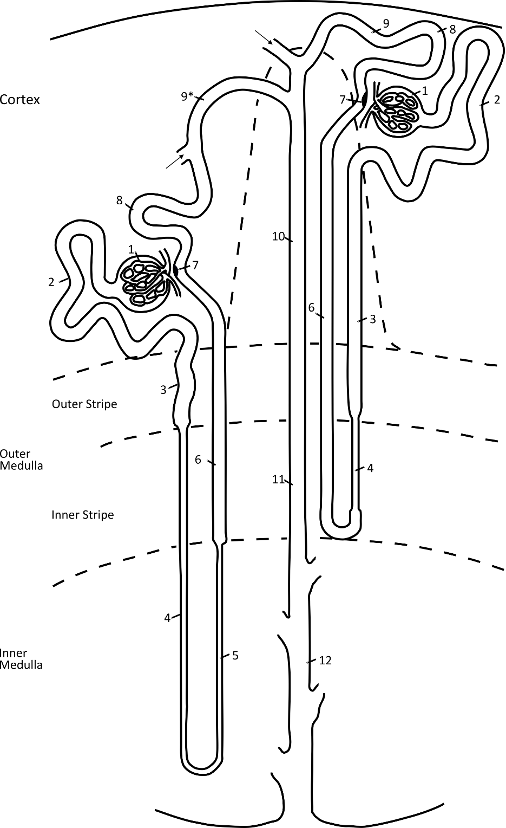

- Glomerulus: podocyte (PODO), parietal epithelial cell, mesangial cell, glomerular endothelial cell
- Proximal convoluted tubule (PCT cell)
- Proximal straight tubule (PST cell)
- Descending thin limb of Henle’s loop (DTL1, DTL2, and DTL3 cells)
- Ascending thin limb of Henle’s loop (ATL cell)
- Thick ascending limb (TAL) of Henle’s loop: medullary (MTAL cell) and cortical (CTAL)
- Macula densa (MD) cell (very low abundance in whole kidney)
- Distal convoluted tubule (DCT) cell (divided into DCT1 and DCT2 cells in some species)
- Connecting tubule (CNT) cell, type B intercalated cell (B-IC), non-A, non-B intercalated cells
- Cortical collecting duct: Principal cell (PC), type B intercalated cell (B-IC), type A intercalated cell (A-IC)
- Outer medullary collecting duct: Principal cell (PC), type A intercalated cell (A-IC)
- Inner medullary collecting duct: IMCD cell

Gold Standard Markers

Cell Type | Gold standard marker(s)
Podocyte | Nphs1 (nephrin), Nphs2 (podocin)
Proximal S1 Cell | Slc5a2 (SGLT2)
Proximal S2 Cell | Slc22a6 (OAT1)
Proximal S3 Cell | Agt (angiotensinogen)
All Proximal Tubule | Slc34a1 (Na-Pi2), Lrp2 (megalin)
Descending Thin Limb Type 1 Cell | Slc14a2 (UT-A2)
Descending Thin Limb Type 2 Cell | Slc14a2 (UT-A2)
Descending Thin Limb Type 3 Cell | Slc14a2 (UT-A2)
Ascending Thin Limb Cell | Clcnka (chloride channel Ka)
Medullary Thick Ascending Limb Cell | Slc12a1 (NKCC2), Umod (Tamm-Horsfall protein)
Cortical Thick Ascending Limb Cell | Slc12a1, Umod
Macula Densa Cell | Slc12a1, Oxtr (oxytocin receptor), Nos1 (nitric oxide synthase 1)
Distal Convoluted Cell | Slc12a3 (NCC)
Connecting Tubule Cell | Aqp2 (aquaporin-2), Scnn1g (γ-ENaC), Calb1 (calbindin)
Principal Cell (CCD) | Aqp2, Scnn1g
Principal Cell (OMCD) | Aqp2, Scnn1g
Type A Intercalated Cell | Slc4a1 (anion exchanger 1)
Type B Intercalated Cell | Slc26a4 (pendrin)
Inner Medullary Collecting Duct Cell | Aqp2, Slc14a2 (UT-A1)

